The Alpha Ceiling and Twin Prime Distribution

**Allen Proxmire**

15 September 2025

# Abstract

We investigate a geometric formulation of prime distribution based on prime triangles and their associated alpha angle. A proved inequality shows that between successive twin prime pairs, the alpha angle of any intervening non-twin prime triangle cannot exceed the alpha angle of the preceding twin. We call this bound the “alpha ceiling”. Any violation would require a prime beyond a computable threshold. Computations up to 5 x 109 support that this threshold is not violated; and the ceiling is not broken. We conclude with conjectures that twin primes set local α-ceilings and bounds on twin-prime gaps throughout the prime sequence.

# 1. Definitions

**Consecutive Primes**: Two primes (*pn​*, *pn*+1​) with no primes between them.

**Twin Primes**: Consecutive primes with gap 2, i.e. (*pn​*, *pn* ​+ 2).

**Prime Triangle**: For consecutive primes (*pn​*, *pn*+1​), define the right triangle with vertices (0, 0), (*pn*, 0), (0, *pn*+1​). As shown in Figure 1.

**Alpha Angle** (*α*): The angle at (0, *pn*+1​), opposite the leg of length *pn* of a prime triangle: *α* = arctan(*pn* / *pn​​*+1). As shown in Figure 1.

**Figure 1**: The Prime Triangle associated with consecutive primes (*pn​*, *pn*+1​).

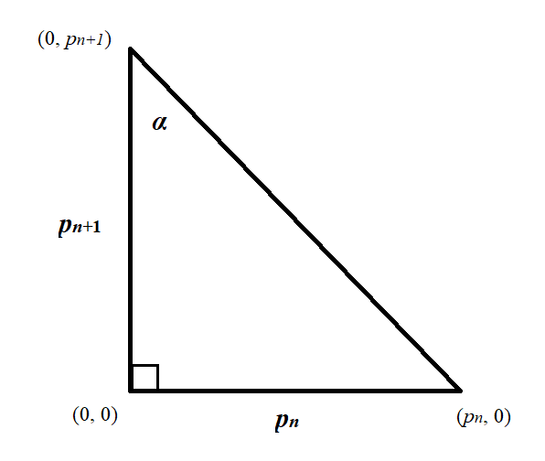

# 2. Lemma: The Alpha Ceiling Inequality

**Lemma**.  
Let (*pn​*, *pn​* + 2) be a twin prime pair. For any consecutive prime pair (*pk​*, *pk ​*+ *gk​*) after it, if *αk* > *αn*, then

*pk* > (*pn*)(*gk*)/2.

**Corollary (Contrapositive)***.*  
Let (*pn​*, *pn*+1​) be a twin prime pair and suppose *pn* *<* *pk <* 2*pn*. Then the consecutive-prime angle satisfies

*αk* ≤ *αn*​​.

In words: any non-twin consecutive prime pair occurring strictly between a twin *pn* and its double cannot exceed the α-ceiling set by that twin.

**Proof**.  
Since arctan is increasing, *αk* > *αn* if (*pk* / (*pk* + *gk*)) > (*pn* / (*pn*+ 2)). Cross-multiplying and simplifying yields 2*pk* > (*pn*)(*gk*), or equivalently *pk* > (*pn*)(*gk*)/2.

Figure 2 illustrates how the twin prime α sets the ceiling.

**Examples**:

• If *gk* = 4, violation requires *pk* > 2*pn*.

• If *gk* = 6, violation requires *pk* > 3*pn*.

• Larger gaps push the threshold higher.

**Figure 2**: The α-ceiling: twin prime α’s set the maximum until a threshold is passed

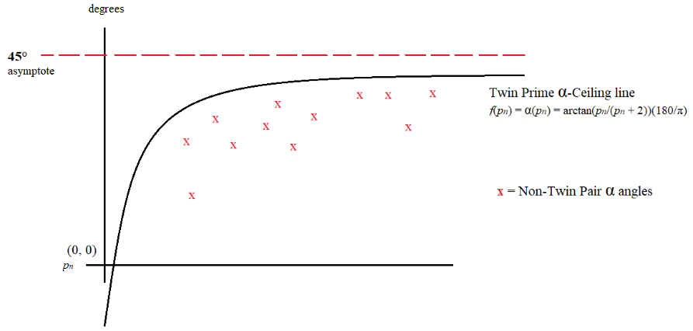

# 3. Computational Evidence and Numeric Implications

The violation thresholds from the *α*-ceiling lemma suggest a natural bound on gaps between consecutive twin primes. Specifically, for any twin prime pair (*pn​*, *pn​* + 2), the earliest possible *α*-ceiling violation for a non-twin gap *g* ≥ 2 occurs at *pk* > (*pn*)(*g*)/2. Applying this pattern to the minimal gap *g* = 2 implies that the next twin prime should occur **before a gap exceeding *pn*​**. Figure 3 illustrates the twin prime gap and condition.

**Figure 3**: Example of the twin-to-twin gap condition, *pm* − *pn​* ≤ *pn​*.

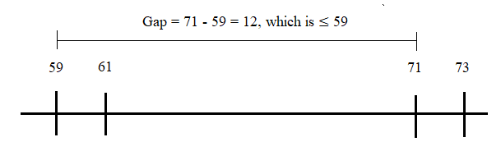

Computations up to 5×109 confirm the following:

* No *α*-ceiling violations were observed.
* For all consecutive twin prime pairs (*pn​*, *pn​* + 2) and (*pm*, *pm* + 2), the gap *pm* − *pn​* does not exceed *pn​*.

These results support the numeric consequence suggested by the *α*-ceiling framework.

# 4. Conjectures

**Conjecture 1 − Twin Prime *α*-Ceiling Conjecture**  
For every twin prime pair (*pn*, *pn* + 2) and the next twin pair (*pm*, *pm* + 2), all consecutive primes (*pk*, *pk*+1) with *n < k < m* satisfy

*αk* ≤ *αn*.

Equivalently, twin primes set local *α*-ceilings that remain unbroken until the next twin.

**Logical gap from Lemma to Conjecture 1.**

The lemma (and its corollary) prove only a local restriction: no consecutive prime pair with base less than 2*pn*​ can exceed *αn*. Conjecture 1 should therefore be read as a conjectural extrapolation of the lemma, supported by extensive computation but not deduced from it.

**Conjecture 2 − Twin Prime Gap Bound Conjecture**For any twin prime pair (*pn*, *pn* + 2) with *pn* > 5, let (*pm*, *pm* + 2) be the next twin prime pair. Then

*pm* − *pn* ≤ *pn*.

Equivalently, the distance between consecutive twin primes never exceeds the smaller twin’s first prime for *pn* > 5.

This conjecture asserts a uniform bound on twin-prime gaps, tighter than any bound currently known.

# 5. Discussion

• The *α*-ceiling lemma provides a clear inequality: violation requires *pk* > (*pn*)(*gk*)/2.

• Applying this pattern to the minimal gap *g* = 2 leads naturally to the bound expressed in Conjecture 2.

• While these conjectures do not prove the infinitude of twin primes, they offer a **geometric and numeric framework** connecting prime triangles, *α*-angles, and twin-prime distribution.

• Computations up to 5×109 support both conjectures: *α*-ceilings remain unbroken, and twin-prime gaps never exceed the previous twin’s first prime.

# References

Hardy, G. H., & Wright, E. M. (1979). An Introduction to the Theory of Numbers. Oxford University Press.

James Grime, *Prime Spirals*, Numberphile, [interview with Brady Haran], https://youtu.be/iFuR97YcSLM?si=UZ64UWcOWxIQ__wZ

Zhang, Y. (2014). Bounded gaps between primes. Annals of Mathematics.

Maynard, J. (2015). Small gaps between primes. Annals of Mathematics.